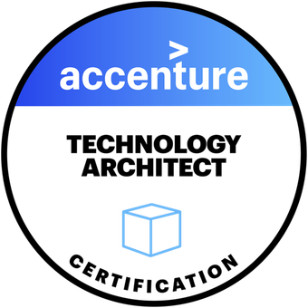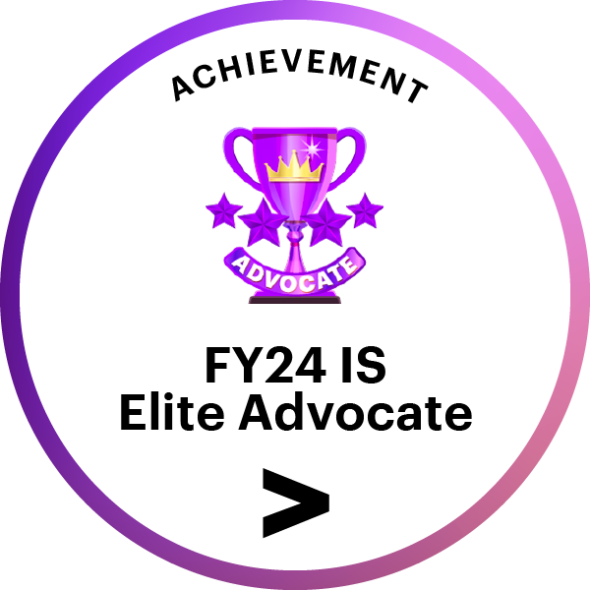 | SIVA SANKARA PADALA  pssreddy87@gmail.com  Mobile: +91-8553817981

Professional Summary
Strategic Application Development Team Lead and BI Specialist with 12+ years of experience in Microsoft 365 ecosystem, cloud migration, and data engineering. Expert in orchestrating large-scale migrations to SharePoint Online, OneDrive, and Exchange Online, leveraging PowerShell, Microsoft Graph API, and Power Platform (PowerApps, Power Automate, Power BI) to automate workflows, enforce governance, and optimize collaboration. Proficient in SQL Server automation, ETL pipeline development, and Azure services to enable scalable, secure, and compliant data solutions. Strong leader with proven success managing distributed teams, driving cross-functional collaboration, and partnering with Microsoft Premier Support to deliver robust, data-driven business insights and self-service governance tools.

Key Skills
- Cloud & Microsoft 365: SharePoint (2010–Online), OneDrive, Exchange Online, Teams, Power Platform, Microsoft Graph API, REST API, Azure AD, Azure Web Jobs
- Automation & Data Engineering: PowerShell, JSON configs, ETL, access certification workflows, DR automation
- Databases & BI: SQL Server, T-SQL, SSRS, Power BI, Report Builder
- Migration Tools: ShareGate, AvePoint, Metalogix, Dell Migrator
- Development: PowerShell, C#, ASP.NET, JavaScript, jQuery, HTML, CSS
- SharePoint Governance: SharePoint Designer, InfoPath, CAML, JSOM
- DevOps & Infra: GitHub, TFS, SVN, IIS

Work Experience
- Working as Application Development Lead in Accenture Solutions Pvt Ltd, Hyderabad form August 2017.
- Worked as Senior Consultant in Capgemini India Pvt Ltd, Bangalore from November 2014 to June 2017.
- Worked as Software Dev Analyst in Dell International Services, Bangalore from November 2012 to October 2014.

Professional Experience

Accenture Solutions Pvt. Ltd. — Hyderabad, India
Senior Software Engineer to Application Development Team Lead & BI Specialist
Duration: August 2017 – Present

Project: ETS
Client: Travelers Insurance
Role: Offshore Team Lead | Microsoft 365 Administrator & Developer
Project Duration: January 2020 – Present
Description: Enterprise-wide Microsoft 365 modernization initiative for a leading U.S. insurance firm, focusing on content migration, automation, and governance to support remote work and compliance.
Technologies: Microsoft 365, SharePoint Online, OneDrive, PowerShell, PowerApps, Power Automate, Power BI, Exchange Online, Azure AD

Key Responsibilities & Achievements:
- Led enterprise-scale migration from SharePoint 2016 to SharePoint Online, ensuring seamless data transfer, governance compliance, and uninterrupted user access.
- Delivered cloud-to-cloud migrations from Google Drive to SharePoint Online and OneDrive using third-party tools and PowerShell, preserving metadata, permissions, and security mappings.
- Developed PowerShell automation pipelines for:
  - Pre-migration analysis and post-migration validation
  - Identified non-user mailbox owners and implemented automated renewal certification processes, supporting access governance and compliance tracking.
  - Scalable, bulk operations across SharePoint, OneDrive, and Exchange Online
- Automated SQL Server backup and restore from Production to Non-Production environments using PowerShell, SQL scripts, and Agent Jobs, enabling consistent environment refresh and disaster recovery.
- Built JSON-driven, configuration-based automation to dynamically load server, database, and disk details — supporting scalable and repeatable operations.
- Implemented routines for permission backup/restore and disk clean-up — improving data security, consistency, and storage efficiency.
- Designed PowerApps and Power Automate solutions for site provisioning, approval workflows, and content lifecycle automation, reducing manual effort and turnaround time.
- Created Microsoft 365 self-service governance tools to manage:
  - Temporary user access
  - Custom scripting settings
  - SharePoint site lock/unlock
  - Synchronization of site and Teams group owners
- Built Power BI dashboards for real-time tracking of:
  - SharePoint/OneDrive migration progress
  - Legacy workflow (InfoPath, SharePoint Designer) usage
  - Power Platform readiness
  - Admin metrics like orphaned users and DL visibility
- Collaborated with Microsoft Premier Support to resolve escalations across SharePoint Online, OneDrive, and Microsoft Teams.
- Automated Microsoft 365 tenant-level admin tasks such as orphaned user clean-up, DL updates, OneDrive ownership transfers, and GAL visibility settings.
- Drove operational efficiency and compliance through proactive lifecycle management, data governance automation, and standardized infrastructure practices.

Project: OASIS
Client: Travelers Insurance
Role: SharePoint Migration Specialist | PowerShell Developer
Duration: March 2018 – December 2019
Description: Migrated departmental sites from SharePoint 2013 to 2016 to enhance knowledge sharing, streamline document management, and improve platform performance and security.
Technologies: SharePoint 2016, SharePoint Online, PowerShell, Power Automate, Power BI, Microsoft Teams, Office 365, SVN

Key Responsibilities & Achievements:
- Managed the migration of content and code from SharePoint 2013 to SharePoint 2016, ensuring seamless content transfer, user access, and site structure integrity.
- Automated key migration tasks using PowerShell scripts, reducing manual effort and ensuring smooth transition of site collections, content libraries, workflows, and custom code.
- Developed and implemented custom Power Automate workflows to simplify approval processes and notifications for content migration and user permissions updates.
- Handled site governance by creating and managing policies for site creation, ownership, and permissions using SharePoint Online features and PowerShell scripts.
- Collaborated with Microsoft Teams to resolve bugs and provide support for clients migrating from SharePoint 2013 to SharePoint 2016.
- Created and maintained Power BI reports to track migration progress, providing insights into the status of migrated content, workflows, and security configurations.
- Delivered user training and provided ongoing support during and after migration to ensure smooth adoption and operation of SharePoint 2016.

Capgemini Technology Services India Ltd. — Hyderabad, India
Consultant to Senior Consultant
Duration: November 2014 – July 2017

Project: Statoil ASA
Client: Statoil
Role: SharePoint Senior Consultant
Project Duration: April 2015 – June 2017
Description: Statoil used SharePoint for internal and external portals to manage department-level documents with different security levels. The project focused on content migration using Metalogix, site provisioning enhancements, and building SharePoint apps hosted in Azure to support document management and collaboration.
Technologies: SharePoint Online, SharePoint 2013, SharePoint 2010, Metalogix, Azure, Visual Studio 2013, TFS

Key Responsibilities & Achievements:
- Guided and supported a team, helping them understand the best ways to work with SharePoint and complete migration tasks smoothly, leading to a successful project.
- Managed weekly timesheet tracking for the team, ensuring accurate and timely submissions in line with project deadlines and client requirements.
- Coordinated and monitored the completion of mandatory training sessions for the team, ensuring compliance with internal and external training requirements.
- Developed and deployed Azure Web Jobs for Office 365 SharePoint Online to automate background tasks and manage job execution in cloud environments.
- Worked on the development of SharePoint-hosted apps and Provider-hosted apps for SharePoint Online, integrating them with Azure services.
- Utilized Metalogix Content Matrix to migrate pages, lists, and content types from an existing legacy SharePoint farm to SharePoint 2013.
- Actively participated in Statoil Quarterly Publication activities, ensuring the seamless integration of SharePoint documents and reports.
- Supported network load balancing by managing redirection of network traffic to ensure high availability and optimized performance.
- Managed SharePoint patches installation, server maintenance, and password management processes to ensure system security and reliability.
- Involved in SharePoint farm administration tasks, including adding/removing servers, changing central admin site configurations, and reducing database sizes through site migration.
- Contributed to change, problem, request, and incident management processes, ensuring that issues were resolved quickly and effectively, minimizing business downtime.

Project: Daimler S4G ITC/PE
Client: Mercedes-Benz
Role: SharePoint Consultant
Project Duration: November 2014 – April 2015
Description: ITC/PE is system to store the documents in lotus notes. Also, it contains Knowledge Base Article Management is an information repository that provides a means for information to be collected, organized, shared, searched and utilized.
Technologies: SharePoint 2013, Lotus Notes, Dell Migrator, JavaScript, jQuery, CSS, SharePoint Designer.

Key Responsibilities & Achievements:
- Installed and configured Dell Migrator for Notes to SharePoint, facilitating smooth migration of Lotus Notes databases to SharePoint 2013.
- Created SharePoint lists, columns, and content types using out-of-the-box features to support structured data storage and access.
- Mapped Lotus Notes fields to SharePoint, including development of user mapping XML files to retain metadata integrity during migration.
- Developed reusable migration jobs to automate and streamline the content transfer process, improving consistency and reducing manual effort.
- Customized SharePoint list forms using JavaScript, jQuery, and SharePoint Designer to enhance UI/UX and form interactions.
- Designed and implemented custom CSS and alternate style sheets to align the SharePoint interface with corporate branding.
- Modified default master pages using SharePoint Designer to deliver a consistent and branded user experience.
- Created Event Receivers to auto-generate article IDs based on predefined logic, ensuring unique and trackable content entries.
- Developed custom Web Parts to display “Recent” and “Popular” articles, enhancing knowledge base accessibility and user engagement.

Dell International Services Pvt Ltd. — Bangalore, India
Software Development Analyst
Duration: November 2012 – October 2014

Project: eTenet
Client: Tenet Healthcare
Duration: December 2013 – October 2014
Description: eTenet is a suite of portals for Tenet Healthcare, providing access to both public and internal sites, including hospital-specific portals. It integrates various applications across HR, Legal, Finance, and Accounting, offering centralized access for employees and stakeholders.
Technologies: SharePoint 2010, SharePoint 2013, Visual Studio 2013, C#, ASP.NET, JavaScript, JSOM, HTML, CSS, CAML, SharePoint Search Service, TFS.

Key Responsibilities & Achievements:
- Upgraded SharePoint 2010 sites to SharePoint 2013 using the Database-Detach and Attach strategy, ensuring data integrity and minimal downtime.
- Developed custom search page layouts using Visual Studio, improving content discovery and search functionality.
- Configured search results using custom result sources and queries to enhance the search experience.
- Created a custom welcome user control to modify the default SharePoint user control, improving the user interface.
- Designed and implemented a custom search page for the search center, offering an enhanced search experience for end users.
- Developed custom search display templates for content search and people search, improving relevance and usability.
- Created feature receivers to add and delete site pages, layouts, and search display templates, streamlining site management.
- Retrieved user profile properties using JSOM to enhance user experience and site personalization.
- Enhanced search result display templates and item display templates for improved content presentation.

Project: AMS
Client: Jones Lang LaSalle (JLL)
Duration: November 2012 – November 2013
Description: Jones Lang LaSalle (JLL) is a real estate client that hosts its applications in a SharePoint 2010 environment. The AMS project involves managing and supporting JLL’s applications using SharePoint’s out-of-the-box features, along with tools like SharePoint Designer 2010, InfoPath Forms, and Visual Studio 2010 to customize and enhance functionality.
Technologies: SharePoint 2010, SharePoint Designer 2010, Visual Studio 2010, ASP.NET, C#, SQL Server 2008 R2, SSRS, Report Builder 3.0, IIS, TFS, jQuery, JavaScript.

Key Responsibilities & Achievements:
- Designed and developed custom SharePoint sites based on user requirements, utilizing SharePoint Designer 2010 workflows to automate business processes.
- Customized default master pages using SharePoint Designer, improving the user interface and aligning with organizational branding.
- Managed permission levels using SharePoint’s out-of-the-box features, ensuring secure and role-based access control.
- Configured SQL Server Reporting Services (SSRS) in SharePoint integrated mode to enable centralized reporting and data management.
- Developed dashboard reports using Report Builder 3.0 and SharePoint to provide real-time data visualization and insights.
- Implemented Export to Excel functionality for selected SharePoint list items, enhancing usability and data handling.
- Built an ASP.NET project management application, hosted in IIS, to track project tasks, milestones, and team performance.
- Leveraged jQuery to dynamically enable/disable navigation elements based on user permissions, streamlining the user experience.

Education
Master of Computer Applications (MCA) – Sri Venkateswara University, Tirupati (Jun 2007 – Mar 2010)

Certifications & Awards
- Technology Architecture Certification – Accenture - Achieved in 2024
- Information Security Elite Advocate – Accenture – Recognized in FY2024
- Microsoft Certified: MS-900 – Microsoft 365 Fundamentals – July 2023
- Microsoft Certified: AZ-900 – Microsoft Azure Fundamentals – August 2020
- Microsoft Certified Professional (MCP) -Achieved via Exam 70-488: Developing Microsoft SharePoint Server 2013 Core Solutions – March 2016
- Certificate of Merit – Department of Computer Science, Vel’s College of Science – September 2009
- Quiz Participation – National Conference on Data Mining & Network Security, Department of Computer Science, Sri Venkateswara University – April 2009

